# DOCUMENTATION OF PYTHON PROJECT

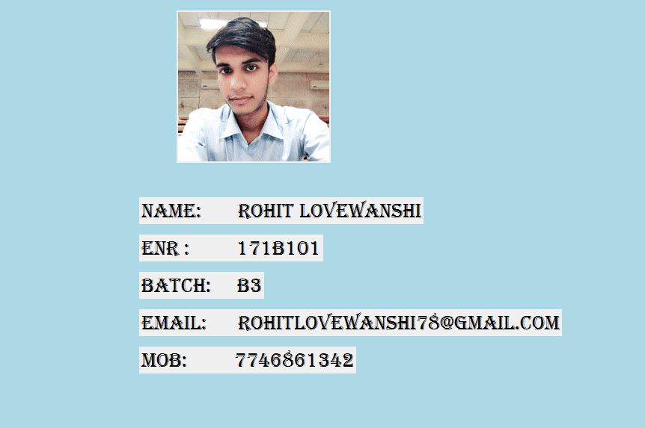

Here , it is my splash screen which shows my biodata and the picture is linked with my project, when cursor is moved it closed and my project open as shown below:

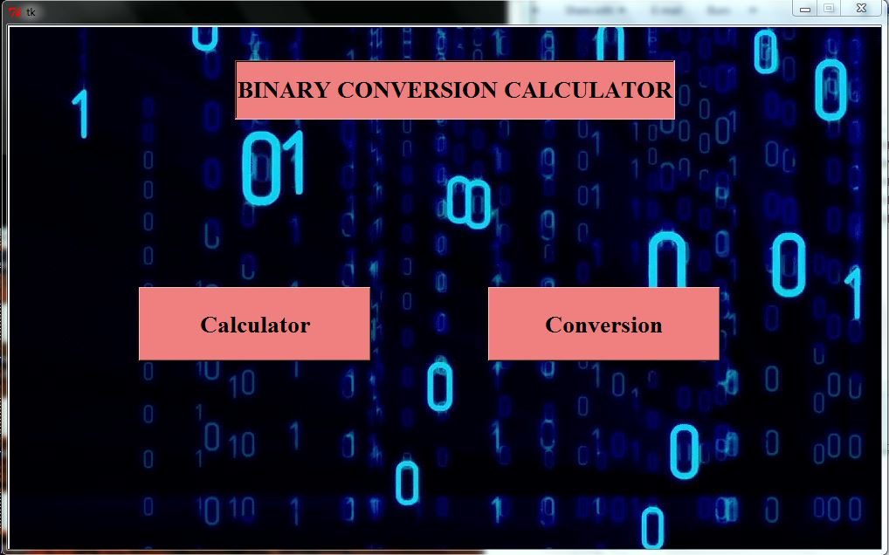

My project name is on the top of the root window i.e. BINARY CONVERSION CALCULATOR

objective: To calculate binary operations and their conversion

In this root window , there are two buttons :

1. Calculator
2. Conversion

1) When we click on the calculator button, new window will open as shown below:

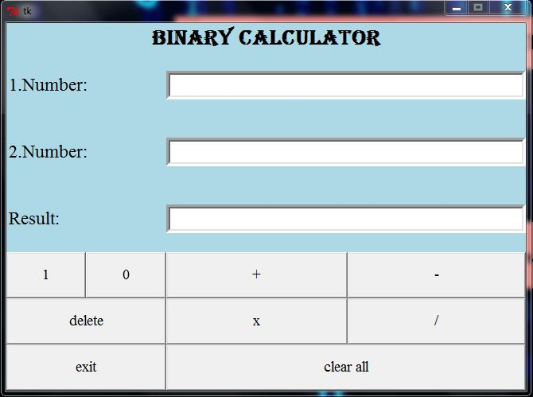

In this window, we will have to enter two binary number in two top entries, then when we click ‘+’ button, the addition of two binary number display in result entry

and same for other operation. ‘clear all’ button clear all entry and ‘delete’ button delete one number and last ‘exit’ button destroy this root window.

2) 1) When we click on the calculator button, new window will open as shown below:

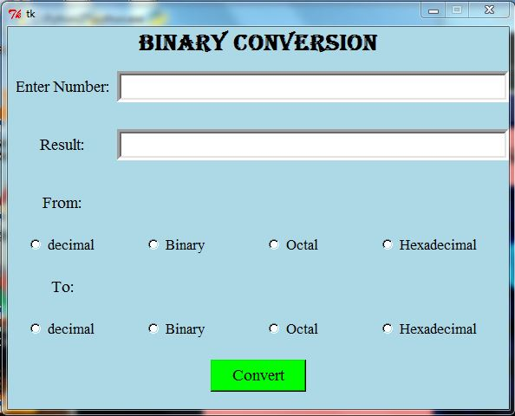Here, we enter one binary number and choose the radio button what do you want to convert and click on the ‘convert’ button and then result will display in result entry box .